Chapter 2 Exercises- Sohil Jain

1. True or False
   1. True
   2. True
   3. False
   4. False
2. C++, Python, Perl, Javascript
3. True or False
   1. True, the computer takes the files and converts it to bytecode so it can read it and it is also the most convenient way.
   2. False, not every computer comes with a compiler, you have to get one yourself.
4. A
5. B
6. True
7. Compiler goes through the whole program and then creates an executable that you can run. Interpreter goes to the program while it runs. JIT Compiler executes code that involves compilation during execution of a program.
8. N/A
9. N/A
10. N/A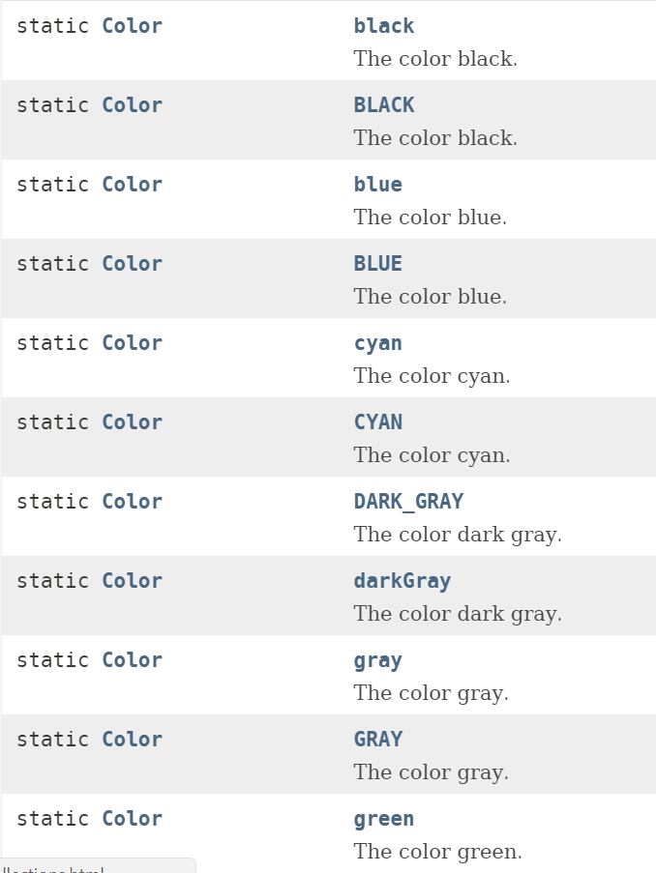
11. N/A
12. N/A
13. Object Oriented Programming is a programming style which is associated with the major concepts of class, object, Inheritance, Encapsulation, Abstraction, Polymorphism